Lecture No. 29 PARASITOLOGY DR.Raad H.H. Protozology

"Piroplasms"
- Classification
Phylum Apicomplexa
Sub class PIROPLASMIA

Order PIROPLASMIDA

Family Theileriidae

Family Characters:
    - merogony in vertebrate host in various cell types such as lymphocytes , histiocytes, erythroblasts, or other cells prior to invasion of erythrocytes; lymph nodes common site.
    - stages invade erythrocytes, which may or may not divide; if they divide, produce 2-4 daughter cells
    - binary fission and merogony occur in tick
    - transstadial transmission
    - all known vertebrate hosts mammals
    - two genera :
      - Theileria; about 40 known species
- small-medium exoerythrocytic meronts; 10-20 micrometers in diameter
- meronts in lymphocytes
- in ruminants
- host specific
- All blood stages have apical complex
- pear- to rod-shaped (smaller than Babesia)
      - Cytauzoon; only 4 known species

Genus Theileria
Theileria parva
life cycle:
- sporozoites injected into cattle with bite of ixodid ticks, especially Rhipicephalus appendiculatus.
- enter lymphocytes
- merogony in lymphocytes; about 90 "macromerozoites" or called "Koch's Blue Bodies" per "macromeront " or called "Macroschizont" ;it is the most risky stage in the disease.
- liberated merozoites enter lymphoid tissues and undergo merogony; about 80-90 "micromerozoites" per second generation "micromeront."
- micromerozoites liberated in lymphoid tissues may invade new lymphoid cells and under merogony as micromeronts; if micromerozoites invade erythrocytes, undergo binary fission (some species undergo erythrocytic merogony)
- micromeronts can induce clonal expansion of the infected host cells
- some merozoites now initiate gamont formation
- gamonts ingested along with blood meal by tick
- in lumen of tick, gamonts differentiate into macrogametes and microgametocytes ("ray bodies")
- 4 microgametes produced; one fertilizes macrogamete; zygote produced
- ookinete (motile zygotes) form and migrate through gut wall
- ookinete enters hemolymph, migrates to salivary glands
- sporogony in acini of salivary glands, releasing numerous sporozoites which remain dormant in salivary glands
Pathology involves high fever, nasal discharge, swollen lymph nodes e.g. periscpular ; precrural ; parotid lymph nodes , runny eyes, weakness, diarrhea, emaciation, and death in 25-90% of the cases, depending upon the species of parasite ,strain , site of tick bite , multiplication rate of macromerozoits (lymph node) , multiplication rate of micromerozoits (erythocytic).
*similar species include Theileria annulata in cattle (Mediterranean coast fever)

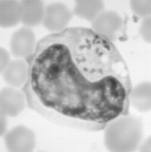
FIG.: Blood smear photograph showing Theileria sp. (sable) schizonts in lymphoblastoid cells. Magnification, x250.

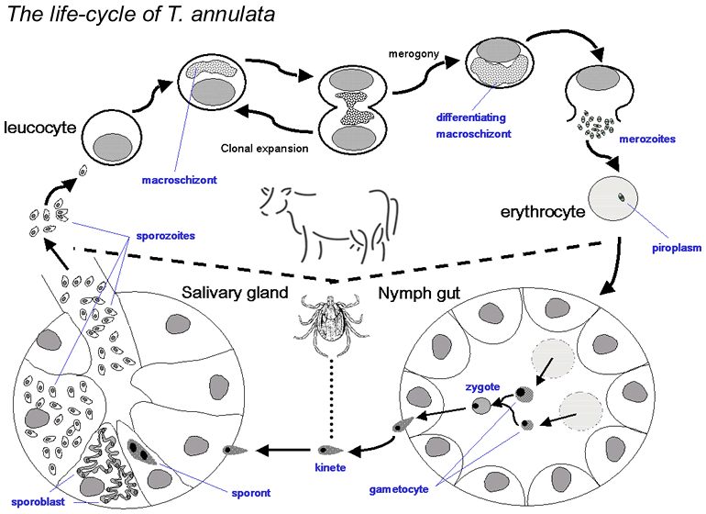

THEILERIOSIS:
Disease caused by Small piriform parasites of red blood cells and lymphocytes of mammals. Theileria parva causes " East Coast Fever" , one of the most important diseases of cattle in eastern and central Africa. transstadial transmission

Epidemiology
- Theileria spp. are transmitted by one, two or three host ticks.
- Theileria parva is transmitted primarily by the brown cattle tick Rhipicephalus appendiculatus
- Geographic distribution: worldwide
- Transstadial transmission
  - Stage-to-stage transmission, i.e. larval to nymph, nymph to adult.
- Factors involved in animal susceptibility :
      - Species of animal
      - Breed : local breed more resistant than imported .
      - Strain
      - Virulence
      - Species of Theileria are host specific
T.annulata | cattle | pathogenic | ++ | Mediterranean Coast Fever | Hyalomma
T.parva | = | Most = | +++ | Bovine Tropical Thelieriosis | R. appendiculatus
T.herci | sheep | = = | +++ | Ovine malignant Thelieriosis | Hyalomma
T.ovis | = | pathogenic | ++ | Ovine begnin Thelieriosis | Rhipicephalus
T.camelensis | camel | mild | + | Camel begnin Thelieriosis | Hyalomma

Clinical signs:
- 1. Clinical syndrome associated with schizogony
- 2. Incubation period 9-24 days
- 3. Enlargement of lymph nodes near site of tick bite
- 4. Fever (41 C)
- 5. Anorexia
- 6. Diarrhea
- 7. Cough and mucous discharge from eyes and nostrils
- 8. Leucopenia
- 9. Anemia
  - Anemia is caused by red cell rupture and by immune-mediated events

Immunity
- Premunition
  - Immunity is based on parasite's continued presence.
Humoral &cellular immunity.

Diagnosis
- 1. Samples of superficial lymph nodes from biopsy or necropsy -Giemsa stain
- 2 Thin blood smear
- 3. Serology
  - a. IFA
  - b. CF
  - c. HAT

Treatment
- Menoctone has been effective against parasites in tissue culture.
- Berenil is not effective against Theileria spp.

Control
- Control tick populations by frequent dipping, spraying, or dusting.

